**Stomatal Conductance Modeling Exercise:** On Dropbox, you will find a dataset containing meteorological observations and tower-derived GPP estimates collected at MMSF during the course of a severe drought occurring in 2012. For the purposes of this exercise, the data are limited to midday (i.e. hour 1300) values.

Use the data to generate estimates of stomatal conductance using the Leuning model, and plant hydraulic model, and the Medlyn optimality model. As a reminder, here are the model forms, and some suggested parameter values:

**Leuning:**

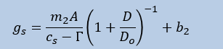

Let:

*D*o = 1.1 kPa

*b*2 = .001 mol/m2/s

*m2* = 6.5 dimensionless

$Γ$ = 50 ppm

**Hydraulic Model**

$$g_{s}= \frac{K\left(Ψ_{S}-Ψ_{L}-pgh\right)}{VPD}$$

Let *K* = 0.3 mol/m2/s

$pgh$ =0.3 (appropriate for a 30-m-tall tree)

Assume constant $Ψ_{L}$ = -1.8 MPa (isohydric species)

**Optimality model**

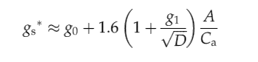

Let go = .001 mol/m2/s and *g*1 = 2.

Visualize the three modeled conductances as a function of time, a function of soil water potential, and a function of VPD. How well do the models agree? Which estimate of conductance is more sensitive to VPD, and to soil moisture, and why? What adjustments to the parameterization scheme might bring the models into better agreement?